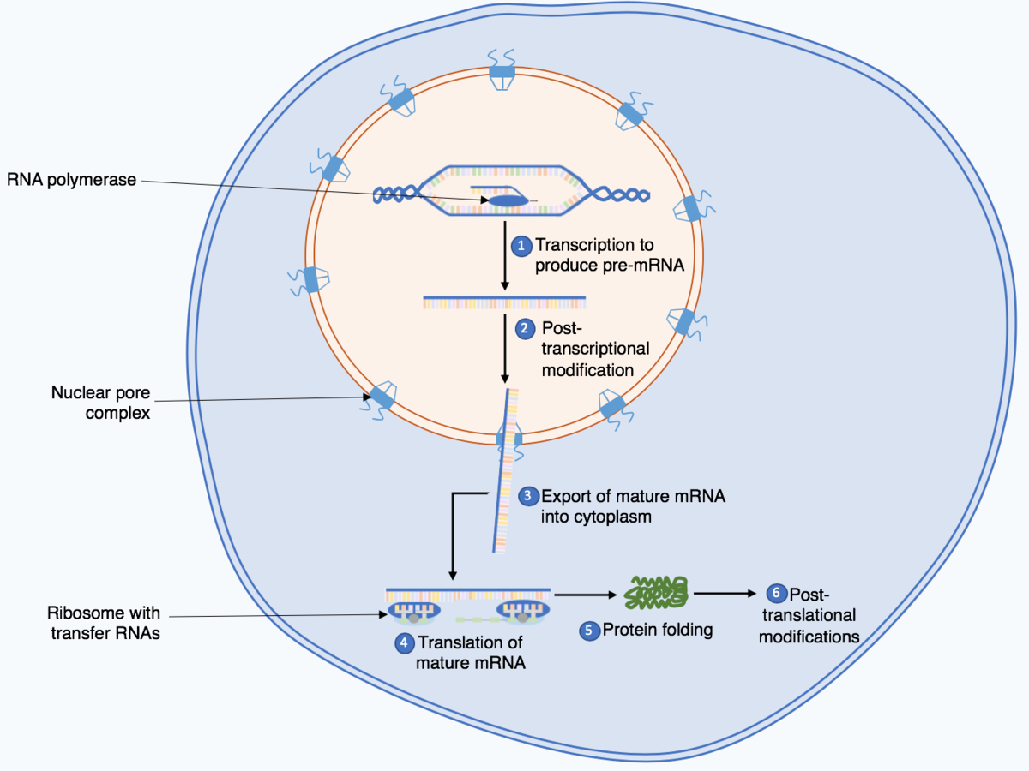
What Is DNA and the Function of RNA?
DNA is a complex, long-chained molecule that contains the genetic blueprint for building and maintaining all living organisms. Found in nearly all cells, DNA carries the instructions needed to create proteins, specific molecules essential to the development and functioning of the body. It also transfers hereditary information between generations.
RNA, or ribonucleic acid, is a family of biological molecules that function in gene synthesis, regulation and expression. Along with DNA, RNA plays an active role in transcribing and translating genes and proteins that make up the human body.
In total, there are three types of RNA that each have their own functions. Messenger RNA are synthesized directly from a gene segment of DNA. Once the messenger RNA is synthesized, it is transported to the cytoplasm. In the cytoplasm, protein synthesis occurs. This process is known as translation and involves ribosomal RNA and transfer RNA. Ribosomal RNA and proteins combine in the cytoplasm to form a ribosome. The ribosome holds all of the enzymes necessary for protein synthesis. It attaches to the messenger RNA and stabilizes it while proteins are synthesized from the genetic code encrypted in the messenger RNA. Next, transfer RNA reads the genetic code on the messenger RNA in the cytoplasm and translates the code into three base amino acids. The amino acids exit the ribosome which is still stabilizing the messenger RNA. The amino acids can then exit the cell to form proteins. Without RNA, none of these processes could occur. RNA allows the cell to create amino acids which aid in gene synthesis, regulation and expression.
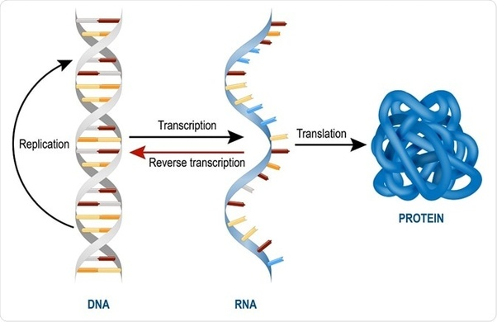

The new mRNA vaccines introduce foreign mRNA into the cell containing its own set of instructions, bypassing the formentioned internal process! Several questions come to mind:
- What is the original DNA strand from which these mRNA injections are created?
- Hydrogel delivery system was needed to ‘trick’ the cell’s defenses into accepting the foreign mRNA. Isn’t this called a Trojan Horse? “Just trust the science”
- Is there an ‘off’ button to the replication of proteins created by the foreign mRNA?
- What happens when two different sets of software code (your mRNA and foreign RNA) have conflicting sets of instructions ? Does this change the cell genome like a retrovirus?
- Can these instructions be transmitted across cells via DNA quantum/photonic communication?
Those that have not taken the mRNA injection are complaining of injuries induced by being in proximity of those who have:
- Painful bruising on the skin
- Rashes and blisters on the skin
- Migraine headaches, dizzy spells
- Irregularing internal bleeding, abnormal menstration, etc.
Symptoms happen within hours of close contact, not days or weeks (ruling out incubation)?
This is transmission, not shedding.

There is a debate among academia, between physicists and biologists in paradigms:
- viewing living cell activity as nothing more than a series of ‘dead’ molecular electrochemical interactions that can be controlled mechanically by ‘cut and paste’ instructions into DNA coding (classical view).
-verses the introduction of recent discoveries pointing to information being transmitted instanteously between DNA strands its cells. Theories are being formed using quantum wave field theory and holographic prinicples. This opens the door to light and electromagnetic field transmission as a carrier of genetic information.

Our bodies emit light

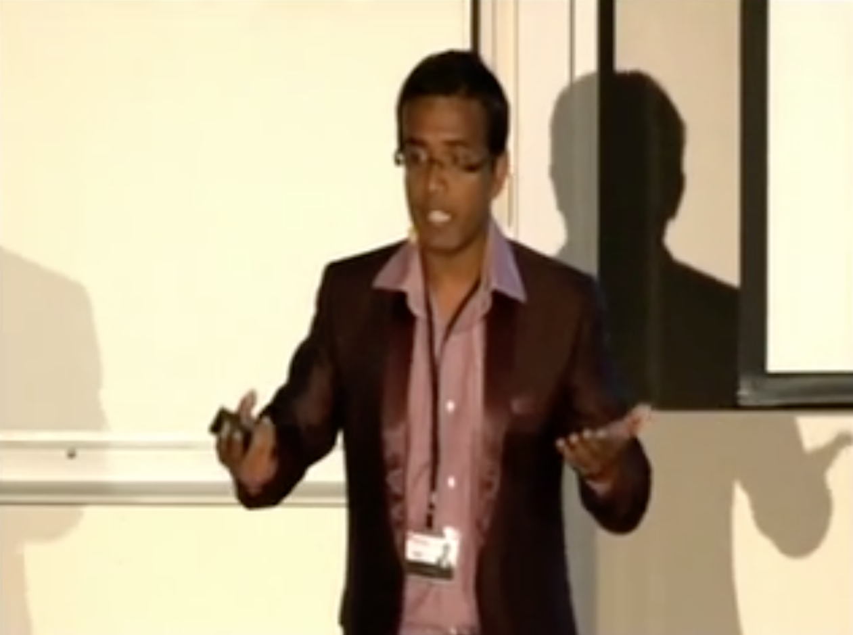
(TEDx 2012 video “Lights of the Living Cell”)
Biophysicist Dr. Ankush Prasad wrote a doctoral thesis titled “Ultra-weak photon emission as an non-invasive method for monitoring oxidative radical reaction”.
His team created a method to detect and measure and photograph light being emitted solely from living objects in a triple-insulated darkened room. His experiments were inspired by the Alexander Gurwitsch onion growth experiments of 1923, verifying what was then termed Mitogenic Radiation, but what is now also known as weak bio-photon emission. This early research also led to the creation of Morphogenetic Field Theory or what is also called the quantum-holographic field.

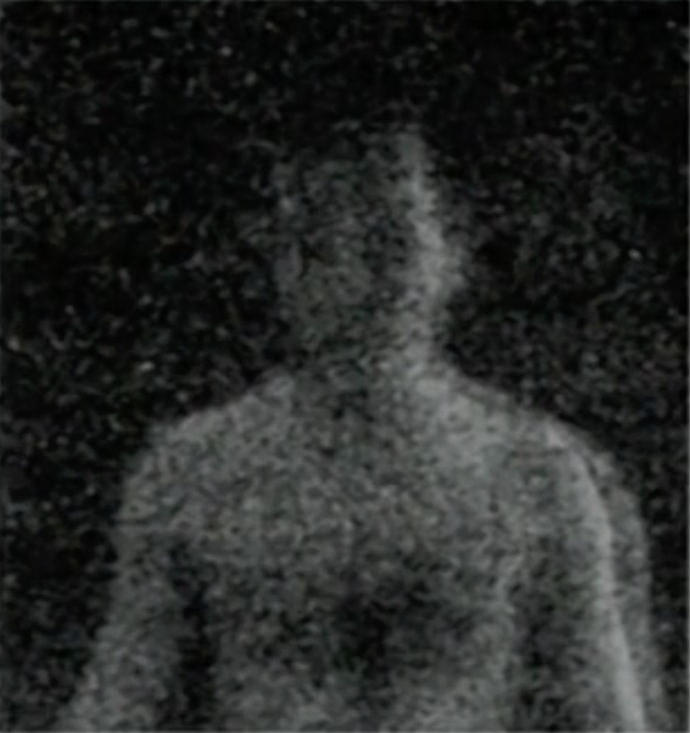
In the groundbreaking research paper the team made the following obervations using a ultra-photon sensitive time-lapse photograpy:
- All living objects emit a light field
- Healthy subjects emit a ‘blue’ spectrum field where ill subjects emit a ‘red’ spectrum field
- Light emission is dependent on stressors in the body. The more cellular activity (i.e. cancer turmor, sickness) The greater the light emission
- When two similar objects were in close proximity the cellular activity of one stressed same raised the cellular activity of the less stressed sample via biophoton interaction

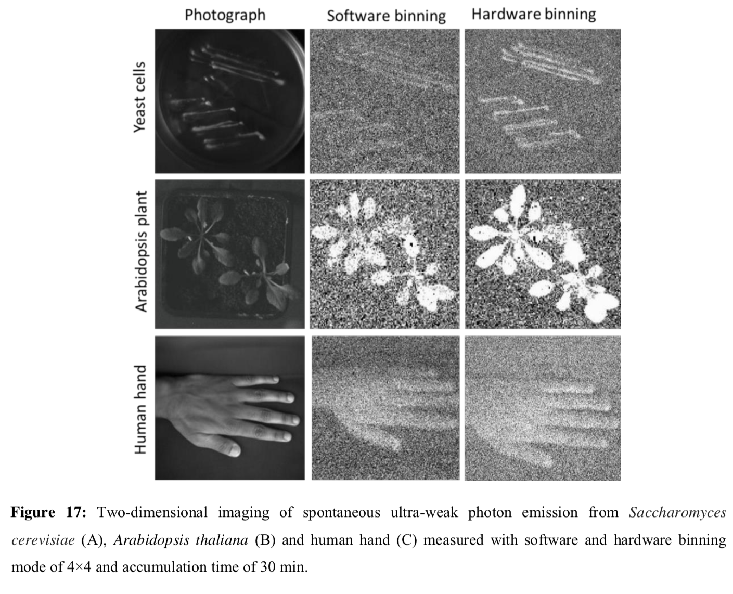
Early illness detection is one of many applications to their findings.
(“Ultra-weak Photon emission as a Non-Invasive Method For Monitoring Oxidative Radical Reaction”, Ankush Prasad)

Beam Interference Technology and Holography?

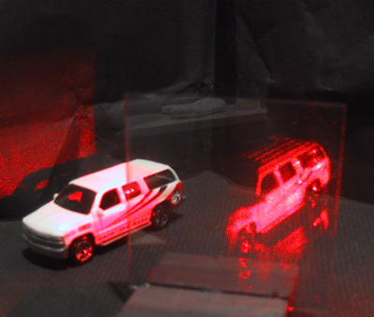
Holography is a photographic technique that records the light scattered from an object, and then presents it in a way that appears three-dimensional. Holography functions on the physical principle of using constructive and destructive interference patterns created by combining the wavefronts of two (or more) coherent beams (i.e. lasers or masers) in order to receive, store, and transmit spacial information.

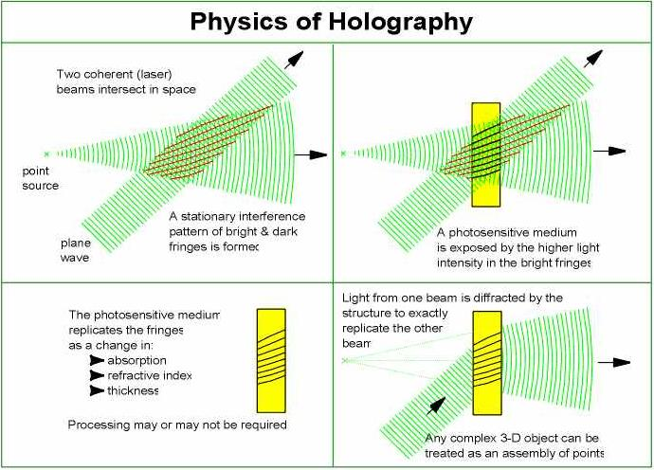

In relation to DNA, it acts as a form of dielectric antenna and more. A receiver and transmitter of information for living cell creation. The code it contains in its structure are keys to replicate the template of the original perfect organism, which exists outside of our domain (Like the virtual image on a holographic plate). Some have call this domain the virtual space, morphic field, holographic field, quantum resonant field, zeropoint, heavenly realm, etc. It is a extra-dimensional realm of coherent information, containing the perfect template for all living things. The mind of God.

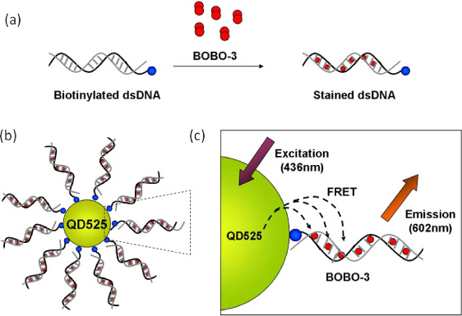
Researchers now have experimental evidence to support the quantum DNA model, and suggest quantum spin states ‘qubits’ can/are stored within its nucleotides:
(Experimental Evidence Supportive of Quantum DNA Model, F. Matthew Mihelic - University of Tennesse Graduate School of Medicine)

A russian study also asserts a new technology, a quantum bio-computer can be constructed based on the quantum wave nature of the DNA molecule. The study also states that beyond the molecular level, there exists two additional orders:
chromosome-holographic - a gene has holographic memory
genome’s quantum nonlocality - the nonlocality of bio-information is realized within the space of organism
(The DNA-“Wave Biocomputer”, Institute Control of Sciences Russian Academy of Sciences, Moscow, Russia)

Interference and Diffraction, holographic techniques used in IoT 5G

5G uses a coherent beam technology to create zones of intersection within large regions using beam-forming and phased arrays.
(Ref. “Millimeter Wave Multi-beam Antenna Combining for 5G Cellular Link Improvement in New York City”)
Example (for illustrative purpose of concept).
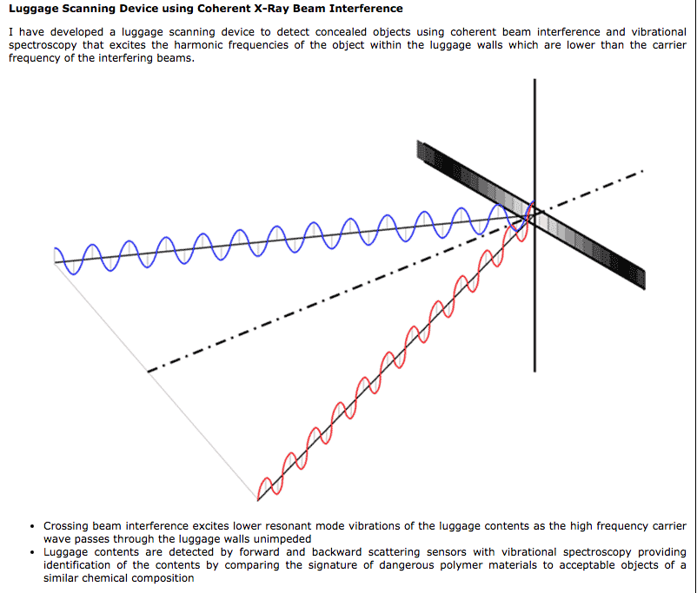

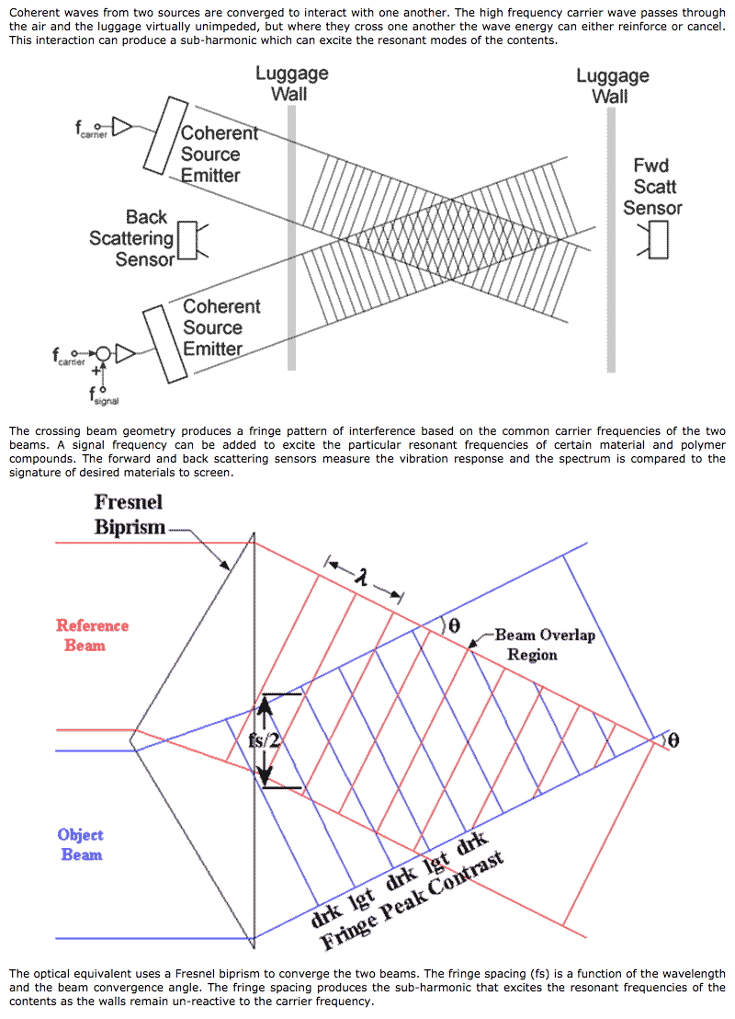

IoT 5G is set to employ very same techniques. These coherent beams can then be used to impact targets while collecting data realtime. The Beam Overlap Region can be a neighborhood or the room of a home.
Does there exist elements within an mRNA injection that can be triggered to emit a known RF signature when immersed in a Beam Overlap Region?
Is the backscatter field emmission of an injected being toxic to those in proximity that are not injected? Are we witness a new form of toxic transmission? Are both bio-photonic and morphic field disrupted?

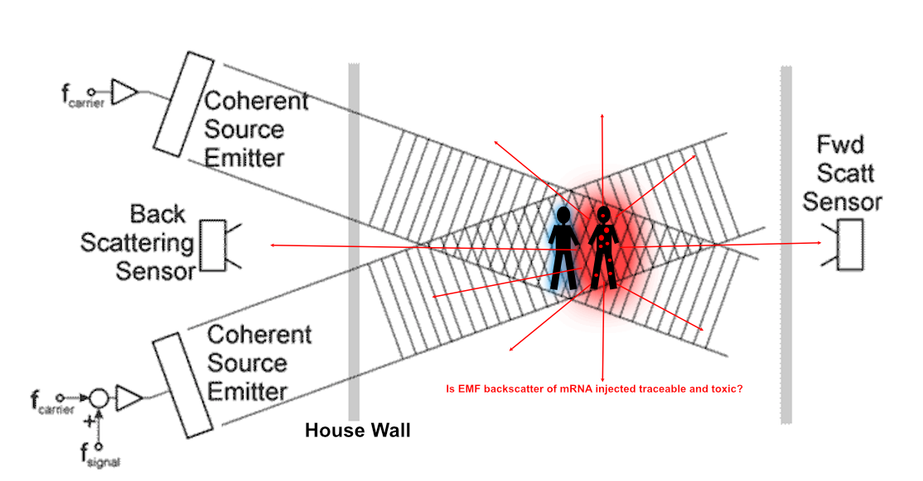
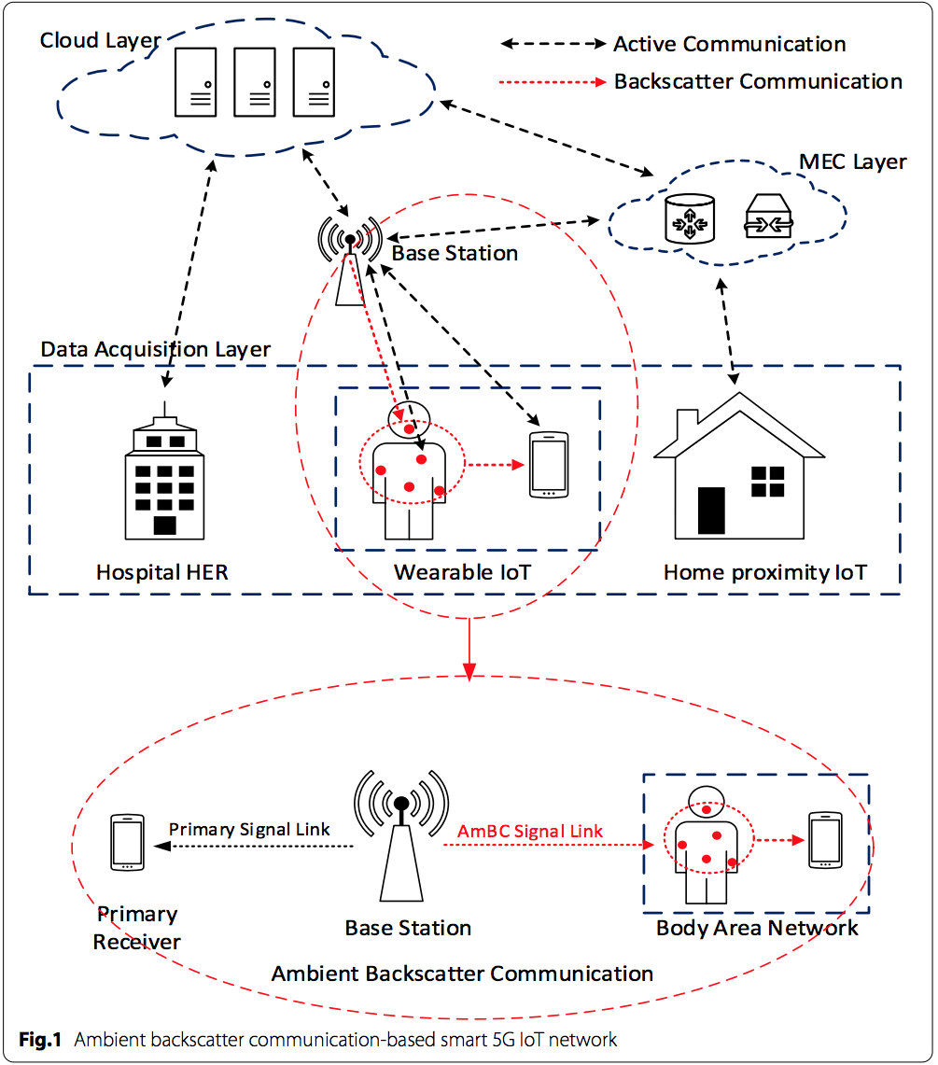
(Fig1 & Fig3, “Ambient backscatter communication-based smart 5G IoT network”)

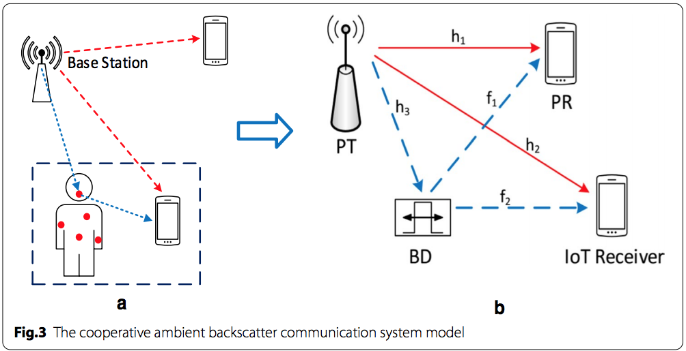

Information is gathered and processed realtime using well-known passive backscatter (diffraction) techniques borrowed from laser holography.
The backscatter can then be processed in the Cloud Layer. Is this the true Track’n’Trace platform?
The backscatter data network contains passive elements that will greatly reduce the cost of total data acquisition.

